Update a File Through a Python Algorithm
Project Description
At my organization, access to restricted content is controlled through an allow list of approved IP addresses. The allow_list.txt file stores these addresses. A separate remove list identifies IP addresses that should no longer have access. My task was to develop a Python algorithm that automatically updates the allow list by removing IP addresses found in the remove list.
This project demonstrates file handling, list manipulation, iteration, and conditional logic in Python.
Open the File Containing the Allow List
To begin, I assigned the file name to the import_file variable and used a with statement to open allow_list.txt in read mode:
import_file = "allow_list.txt"

with open(import_file, "r") as file:
ip_addresses = file.read()
The with open(..., "r") statement safely opens the file for reading and automatically closes it afterward. The .read() method converts the file contents into a single string so it can be processed further.
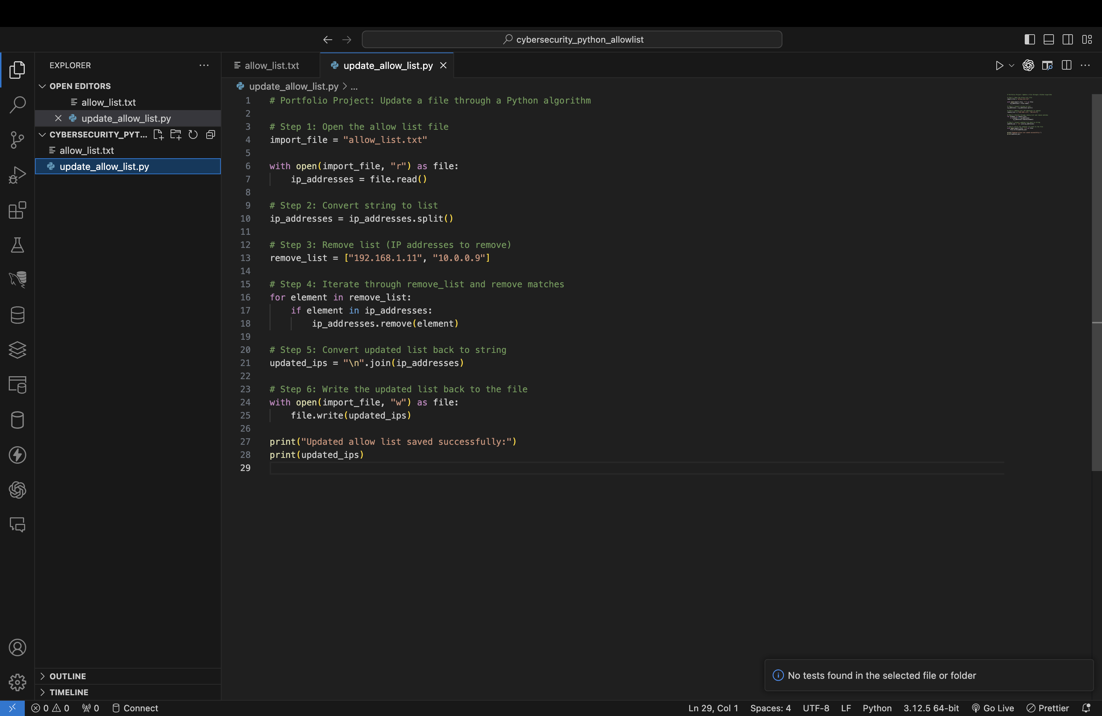
Convert the String Into a List
After reading the file into a string, I converted the string into a list using the .split() method:
ip_addresses = ip_addresses.split()
The .split() method separates the string at whitespace and turns each IP address into an individual list element. Converting the string into a list allows the algorithm to easily remove specific IPs.
Iterate Through the Remove List
Next, I created a remove_list variable that stores IP addresses needing removal. Then, I used a for loop to iterate through each IP address:
remove_list = ["192.168.1.11", "10.0.0.9"]

for element in remove_list:
if element in ip_addresses:
ip_addresses.remove(element)
The loop checks each IP in the remove list. If an IP is found in ip_addresses, the algorithm removes it using the .remove() method. This ensures only authorized IPs remain on the allow list.
Update the File With the Revised List
Before writing the updated IP list back to the file, I converted the list back into a string using .join():
updated_ips = "\n".join(ip_addresses)
The newline character "\n" ensures each IP appears on its own line.
Finally, I used another with statement to open the file in write mode and overwrite its contents:
with open(import_file, "w") as file:
file.write(updated_ips)

print("Updated allow list saved successfully:")
print(updated_ips)
This recreates the allow list with only the remaining valid IP addresses.
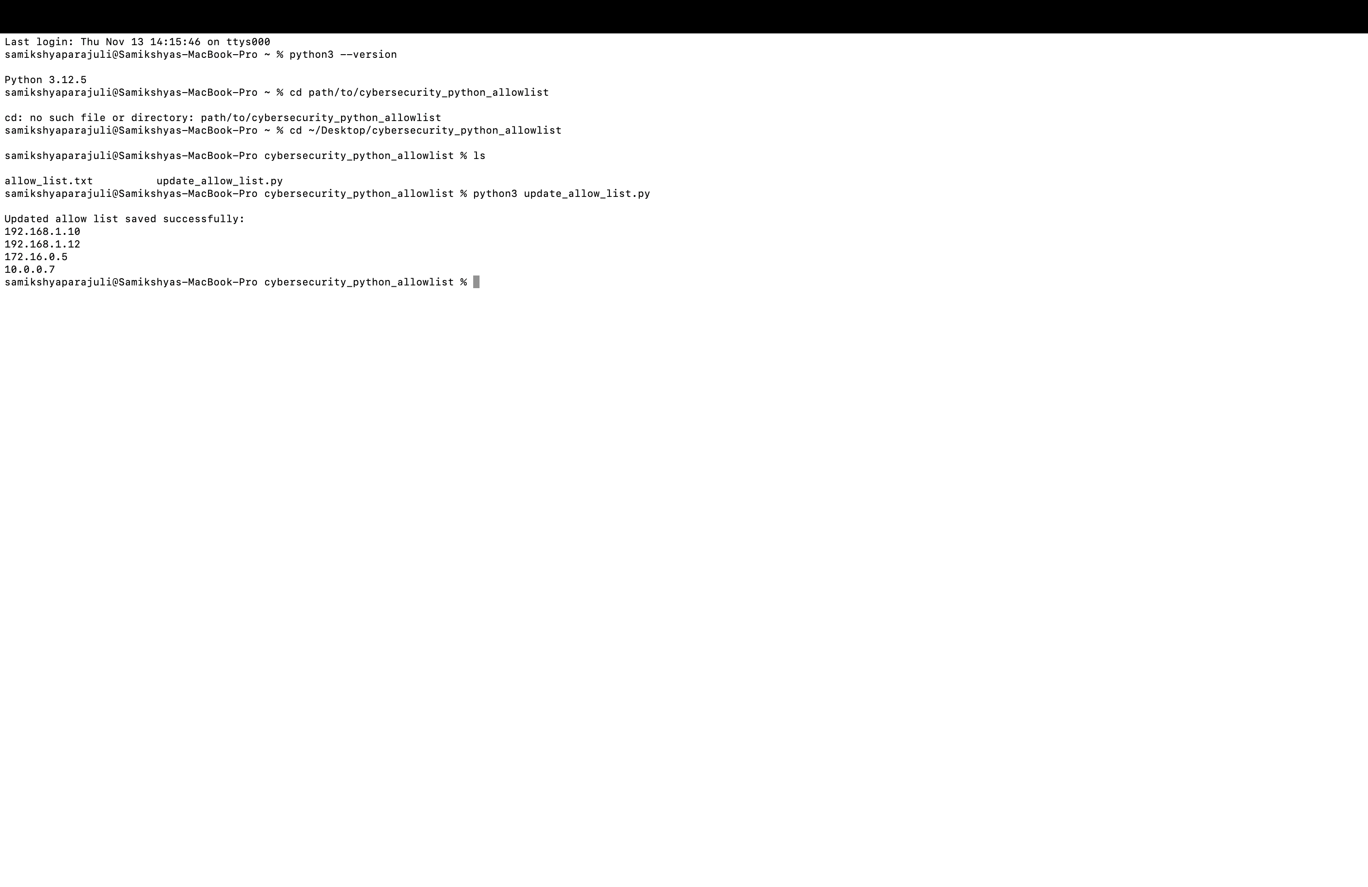Summary
I created a Python algorithm that automatically removes outdated IP addresses from an allow list used for controlling access to restricted content. The program opened the allow list file, read its contents, and converted them into a list. I then iterated through a remove list and deleted any matching IPs from the main list. After updating the list, I converted it back into a string and rewrote the allow list file with the revised data.
This automated process ensures that access permissions stay accurate and up to date while reducing the risk of unauthorized access to protected systems.

